Excel Quiz Nov 2016

Name: _____________________________

Multiple Choice

- How would you properly identify a range of cells? Starting from where to where?
  - Top left cell, bottom left cell
  - Top left cell, bottom right cell
  - Bottom left cell, top right cell
  - Calling up Ossining prison and ask for a blueprint
(Note: This is not the answer)
- There are three types of data that you can place into any cell. Which type of data below is not an example of data?
  - Text
  - Formulas
  - Images
  - Numbers
- What is the shortcut key combination for Undo?
  - [CTRL] + [C]
  - [CTRL] + [V]
  - [CTRL] + [X]
  - [CTRL] + [Z]
- Every formula begins with a(n)
  - Parentheses
  - Equal sign
  - Multiplication sign
  - Addition symbol
- What is the button on your keyboard to push when creating an absolute cell reference?
  - [ESC]
  - [Enter]
  - [B10]
  - [F4]
- If you were trying to group a bunch of cells A5:A10 together as one cell, you would use the following feature of Excel:
  - Absolute cell reference
  - Merge and center
  - Word wrap
  - [CTRL] + [C]
- Which formula does not give the same answer as the rest?
  - =A1+A2+A3
  - =SUM(A1-A3)
  - =A1+(A2+A3)
  - =SUM(A1+A2+A3)
- What is not part of the order of operations? (The order in which stuff is calculated
  - Root numbers
  - Parentheses
  - Exponents
  - Multiplication
- Which function is used to find the highest number within a group of values?
  - Sum( )
  - Min( )
  - Max( )
  - Average( )
- The area within the parentheses of a function-based formula is called:
  - Italian-style fight
  - Argument
  - Range
  - Function

Fill In Questions:

- Explain in words what the sum formula does.

- Create a formula in cell F5 that adds up the totals for Tolos Bouras:

A B C D E F
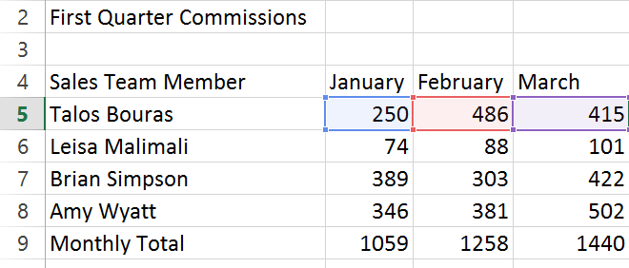

- When building a formula, copying values from one cell to another, checking the validity of data, or simply typing numbers that may go into random cells of a spreadsheet, explain what we emphasized in class you should be doing with your left and right hands at all times.
Keep it clean.

- What is PEMDAS?
What do each of the letters stand for?
- Not counting the SUM( ) formula, please describe one other formula in detail. You should include:
a. The name of the function
b. How it is written
c. Explain its purpose
d. Provide an example

Hands-on exercise: Create the following spreadsheet, and perform three of the colored exercises indicated in the tables below.

Instructions on next page for each color.

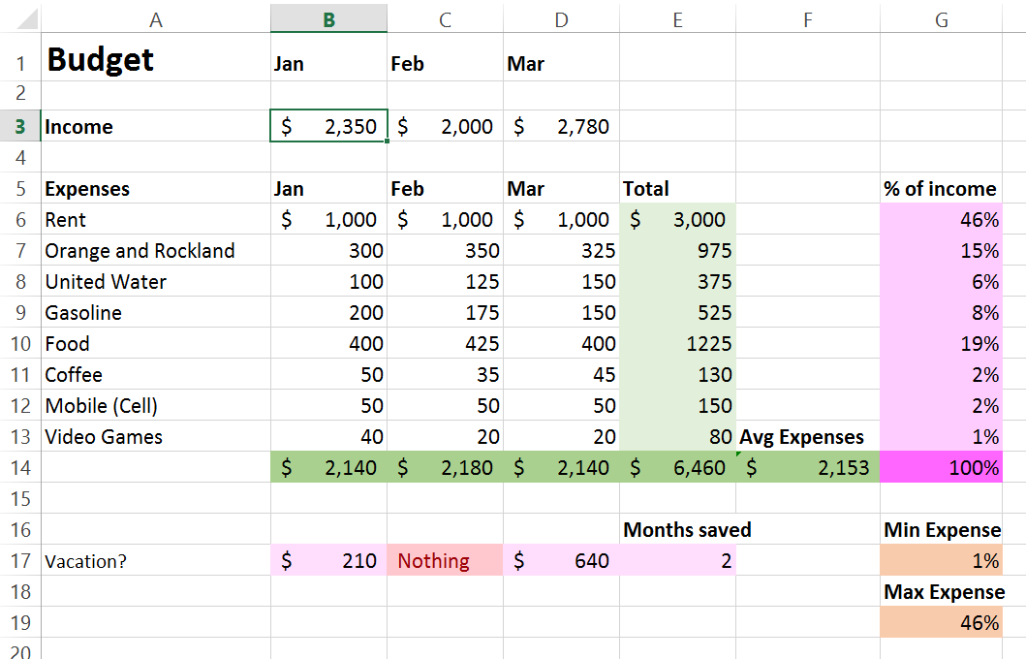

Green: Sum Formulas. Total up the Jan / Feb / Mar numbers, then do totals for all at the bottom of each column | Pink: Divide each light green total by the overall (dark green total). Use absolute cell reference | Red: Use conditional formatting or IF statement to identify how much money (if anything, you’ve saved this month)
Orange: Average of the column totals (the ones that are in green), The min and max expenses of the pink items, and the count of how many months you saved money for vacation (pink) | Overall: Format the spreadsheet, make it look nice. Use borders, colors, and other features we learned | Extra credit: Come up with your own cool formula to identify something interesting on the spreadsheet. Use your imagination.

